# DIDSON and Tower Visualization and Compare

Sam Graf sfigraf@gmail.com

Location: T:\Natural_Resources\Projects\Biologic\Fish\Salmon\LkClrk_Escapement\Data Analysis\DIDSON vs Tower Visualization

Purpose:

* Visualization of observed daily and hourly salmon counts from all read DIDSON files and tower counts
* Comparison of paired counts between DIDSON and Tower and observation of outliers in conjunction with qualitative weather observations
* Yearly weather visualizations

## Motive/Synopsis

Sonar counts can be used as a method to check accuracy of tower counts, especially when environmental conditions are less than ideal (high wind, excessive turbidity, low light etc). This project is meant to visualize raw sonar and tower counts and compare them against each other, using environmental variables to help explain discrepancies. I first visualized tower and sonar counts from 2021 in R before building an app with the RShiny framework to take data from all years. Using the RShiny framework creates an interface that allows users to interact with the data without needing to change anything to the underlying code. I have options to upload user-selected files of both sonar and tower counts to the app, as well as weather, and plots will automatically be generated. This way, different files can be uploaded, and different years can be examined. In this way, the app will work for any future files that are created, so long as they are similar format to the files already used.

## How to Open through RStudio

Assumes that R and Rstudio are both downloaded and other code can be run without issues

1. Navigate to path specified above and open “didson_vs_tower.Rproj”
2. Open didson_vs_tower_app folder from the “files” pane in the lower righthand of RStudio and open either the ui.r or server.r file, if they’re not already open

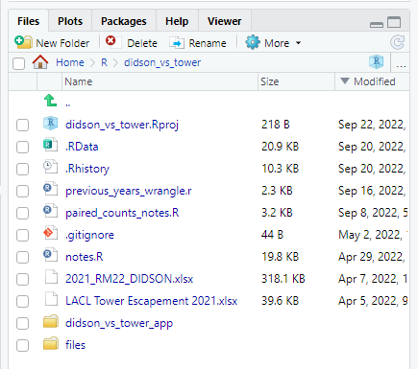

1. Click “Run app”. There may need to be some packages/dependencies installed.

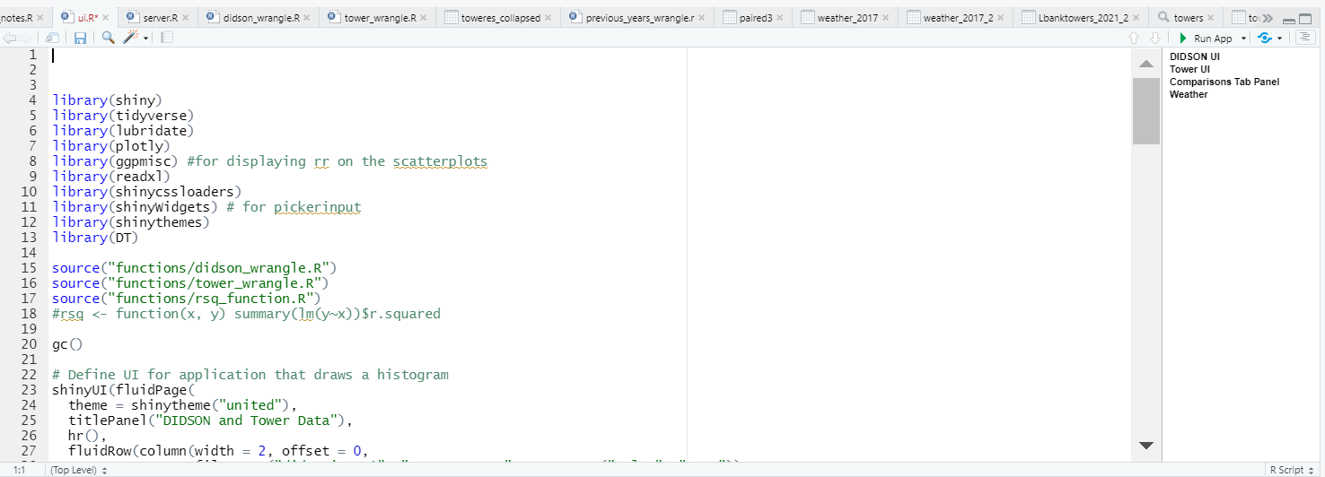

1. You should see this interface

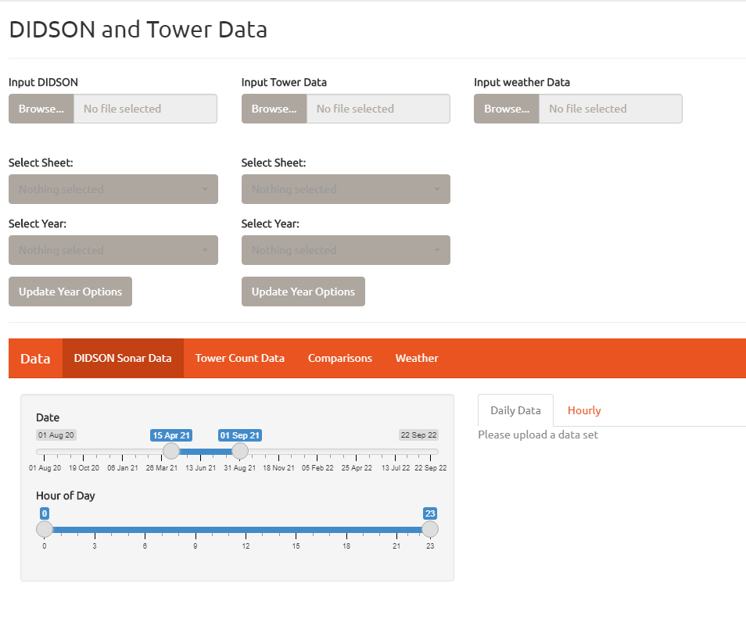

## Interacting with the App

### DIDSON Tab

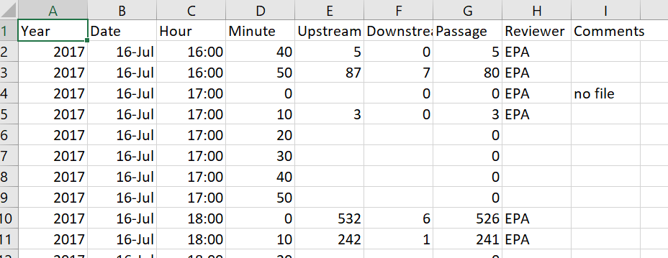The Input file options both work with .xlsx and .csv files, but they work best for .csv files. For the DIDSON file upload, I will generally use DIDSON_RM22_2017-2021.csv, which contains all Sonar data since 2017. Note that not all files are read, and some hours have some counts read more than others.

Once you upload a file, select the desired sheet if you uploaded a .xlsx file. If you uploaded a .csv, click “update year options” to get different year options.

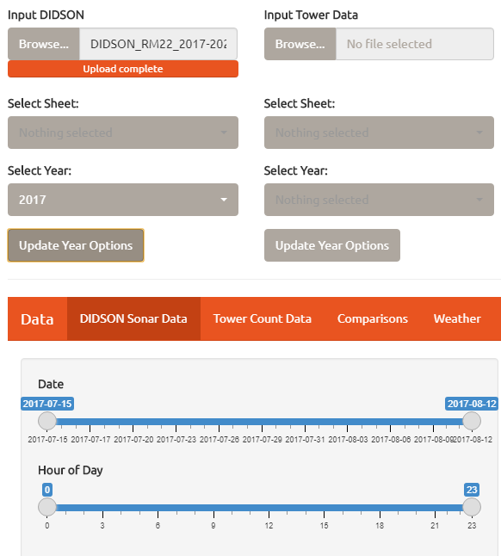

Once a year is selected, the Date slider will automatically update, and so will the displayed plot.

On this tab, the raw counts from each hour/day are filtered. Since some hours are read more than others, the summarized counts will be greater for certain hours. In the future, a filter for this could be implemented.

### Tower Tab

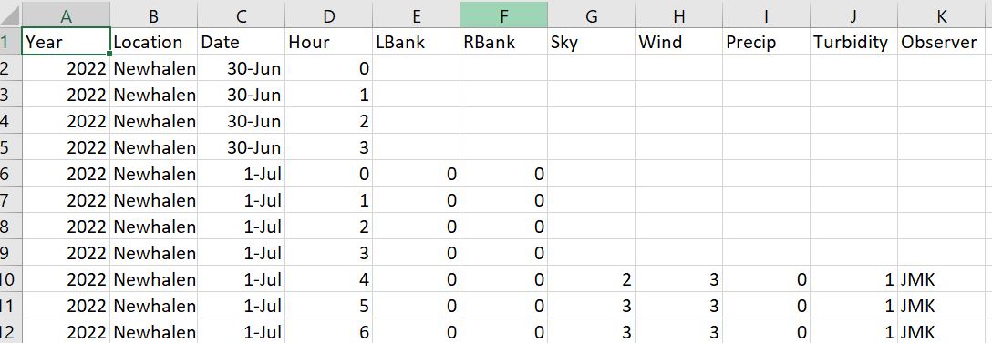For the Tower file I will generally use 2022 Newhalen River Master Hourly counts.csv, containing all tower count and qualitative environmental data starting from 2000. Note that a lot of years don’t have this qualitative weather data

Just like the DIDSON file, you need to select the correct sheet if you uploaded a .xlsx file and click “update year options” to select a year and get the data to display.

### Comparisons

To show comparisons between DIDSON and Tower Count Data, select the same year under the DIDSON and Tower dropdown menus and then click “Update Slider and Render Data”.

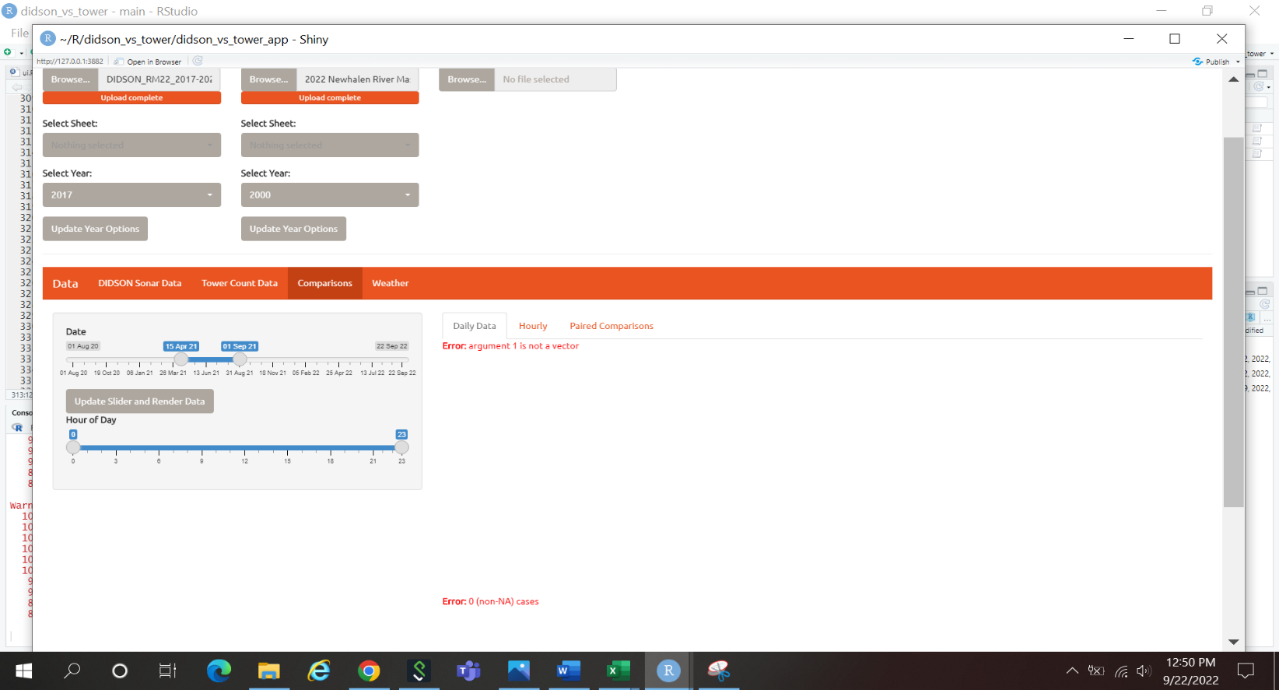

For the Daily Data and Hourly data comparisons, only the raw counts are compared. There are no corrections applied to the data.

Under the “Paired” Tab, Tower counts are filtered to only include Left Bank counts (counts that started on the 50-minute mark for even numbered hours aside from hours 0 and 2, and counts that started at minute 0 for odd numbered hours). DIDSON counts are filtered to only include counts starting at 50 minutes and 0 minutes.

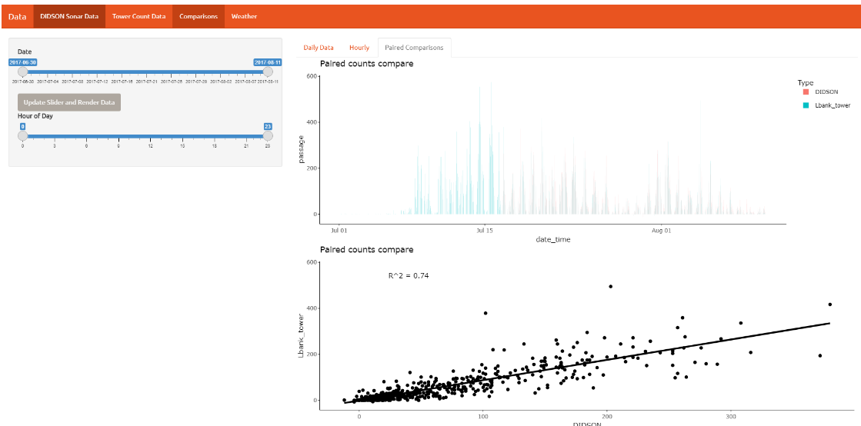

You can see qualitative weather data when hovering on a specific data point. The scatterplot is especially useful in seeing differences.

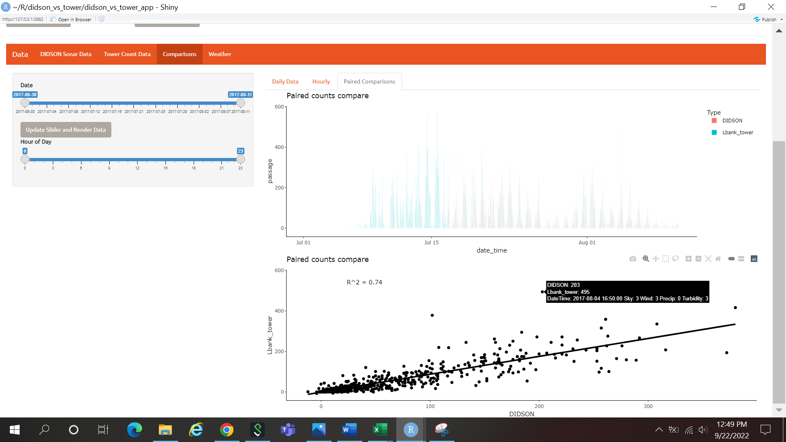

## Weather

You can upload quantitative weather .csv files from different years and view their interactive plots as well.

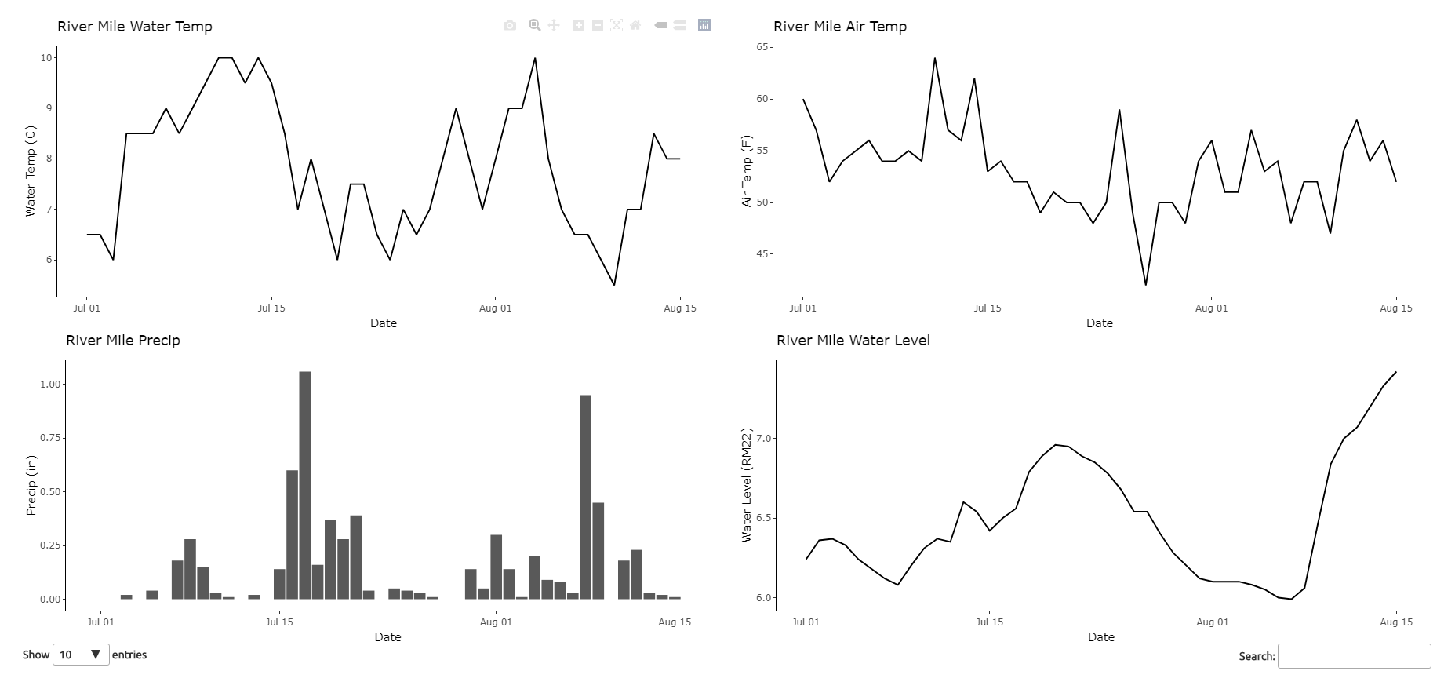

## Future Improvement and Questions

Add a filter in DIDSON tab to select sonar files from certain timeframes you want to view. For example, “use only sonar files read from minutes 0-10 on the hour”. This could allow you to make a less biased Hourly plot and estimate percentage of the run during each hour more effectively. Adding this functionality would help answer the question “During which hours does the highest percentage of the run occur?”

Add in automatic labelling of outliers in the DIDSON vs tower paired scatterplot. I tried to do this and ran into some road blocks. In my opinion this wouldn’t be a huge priority because you can zoom in to the plot and decide for yourself if it’s worth going back and looking at.

Add in Temperature data from HOBOloggers once it is cleaned and entered in Aquarius.

Add in functionality to actually enter new data as the run progresses and view graphs in realtime. You could compare current data against previous years, build in corrections for counts that are missed as well as daily estimation, helping to reduce human error.

Generate summary statistics of the run and create simple correlations with environmental data with methods like ANOVA, t-test, chi-squared. This coupled with adding temperature data would help answer the question “Which environmental factors influenced the timing of the salmon run during which years?”

Add in corrections to DIDSON and Tower counts to display data as they are reported as the estimated run. Basically, multiplying the tower counts * 6 and adding that correction factor for hours 0-4. This is done elsewhere, but it could help users of the app see the difference in the raw counts versus the estimated counts.

Happy to add to this if needed!